SCREENSHOTS

- What are the top 10 aisles with the highest number of products?

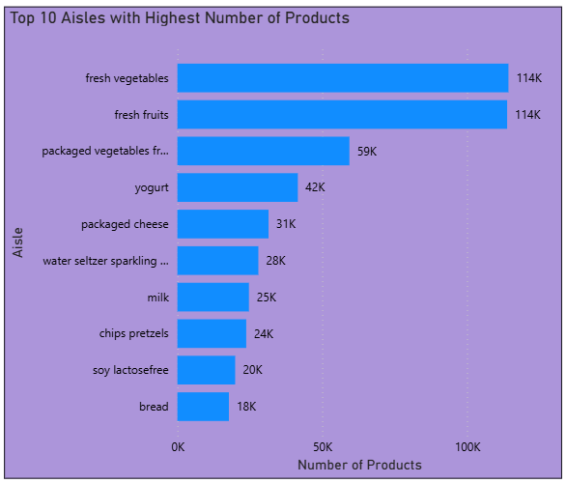

- How many unique departments are there in the dataset?
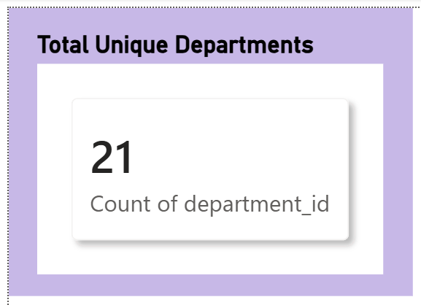
- What is the distribution of products across departments?
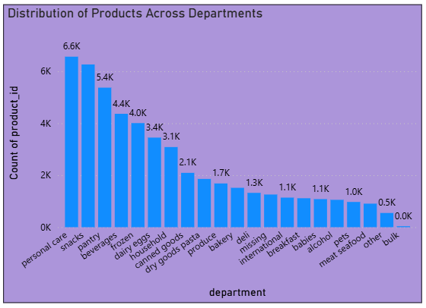
- What are the top 10 products with the highest reorder rates?
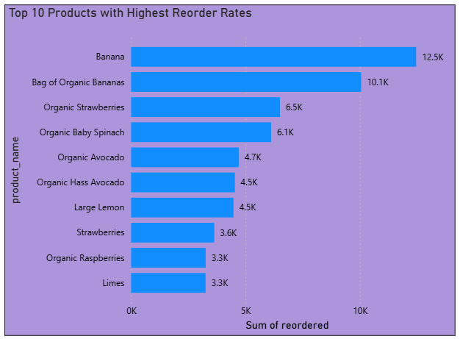
- How many unique users have placed orders in the dataset?
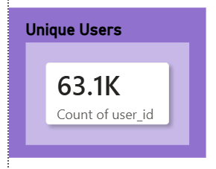
- What is the average number of days between orders for each user?
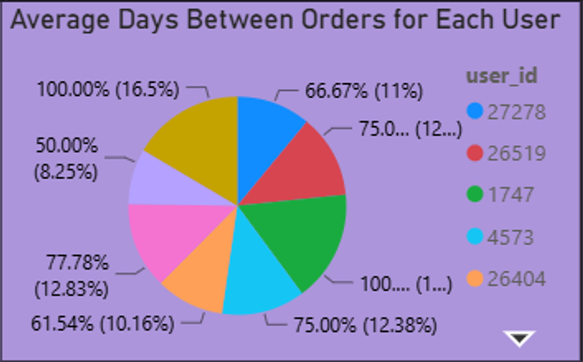
- What are the peak hours of order placement during the day?
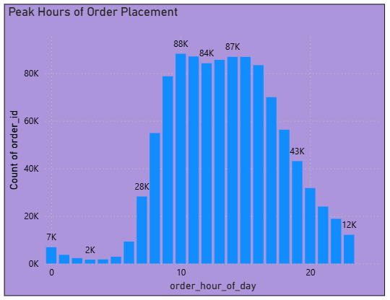
- How does order volume vary by day of the week?
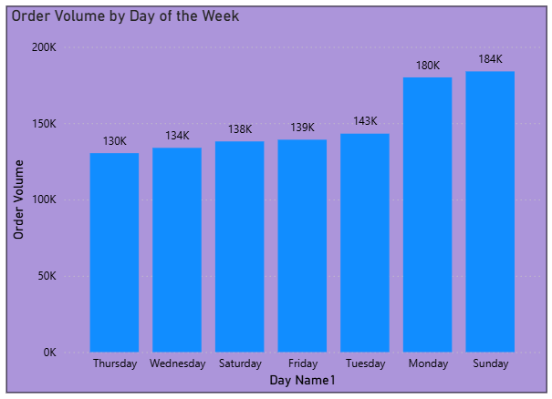
- What are the top 10 most ordered products?
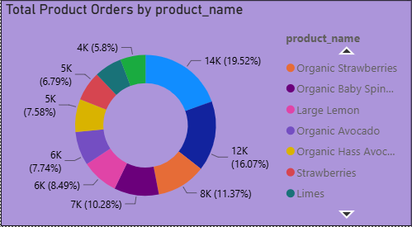
- How many users have placed orders in each department?
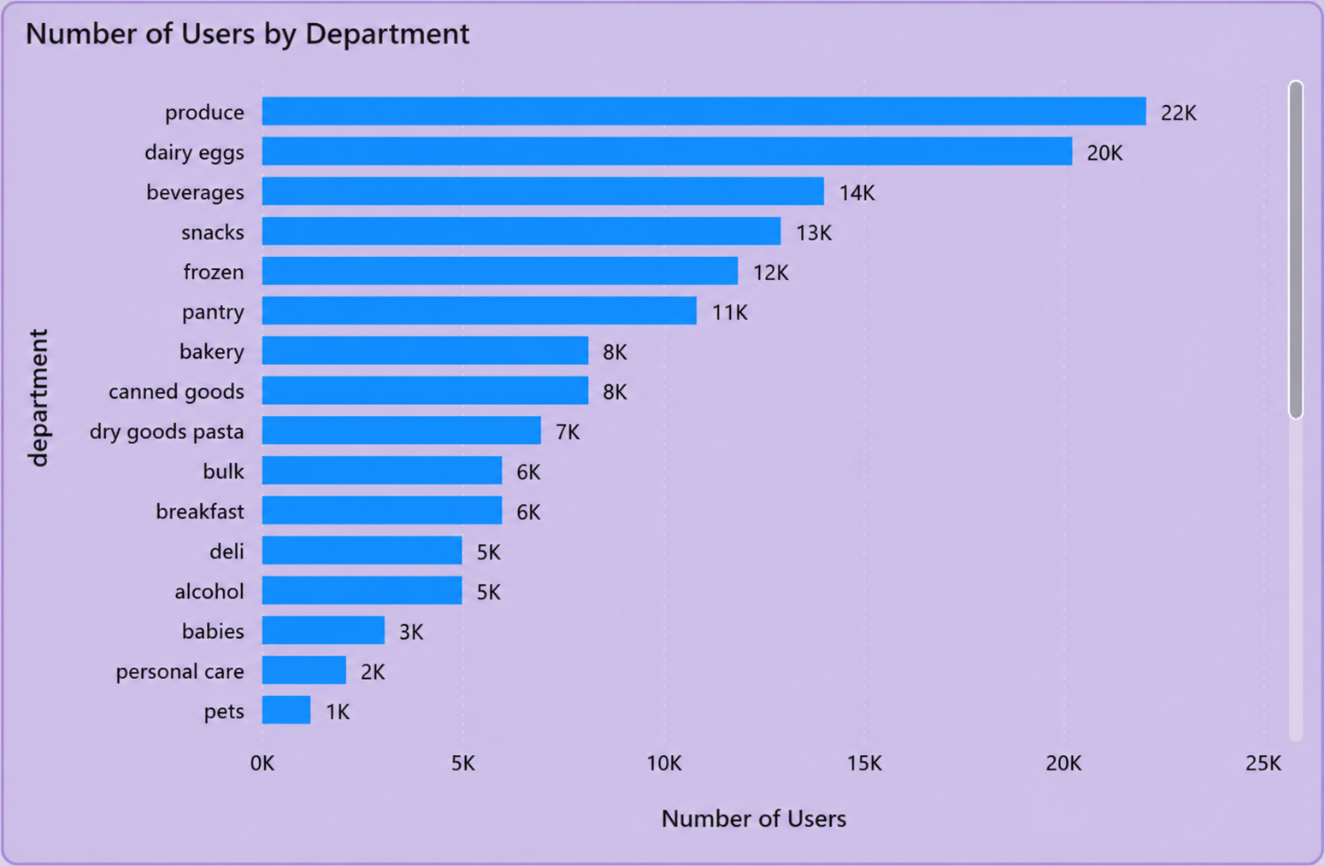
- What is the average number of products per order?
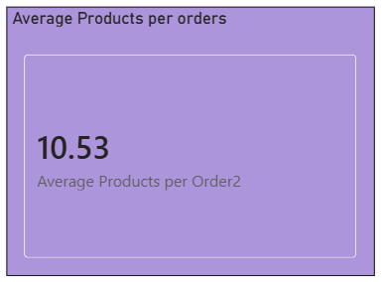
- What are the most reordered products in each department?
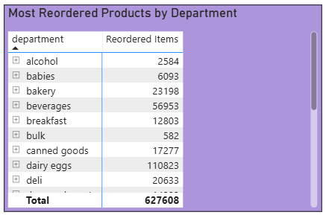
- How many products have been reordered more than once?
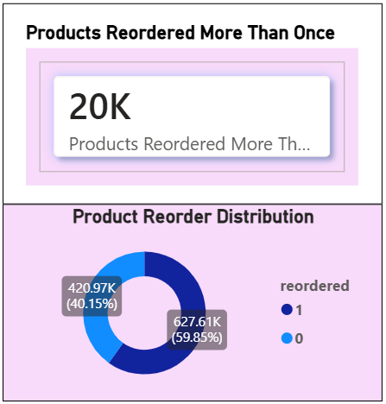
- What is the average number of products added to the cart per order?
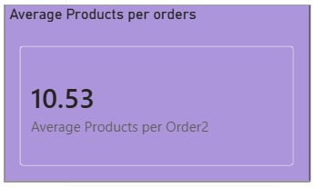
- How does the number of orders vary by hour of the day?
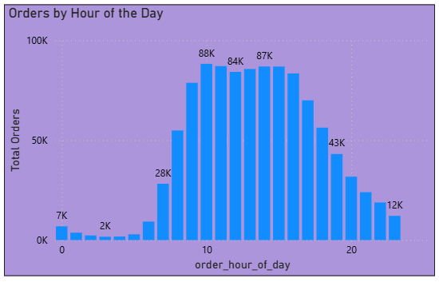
- What is the distribution of order sizes (number of products per order)?
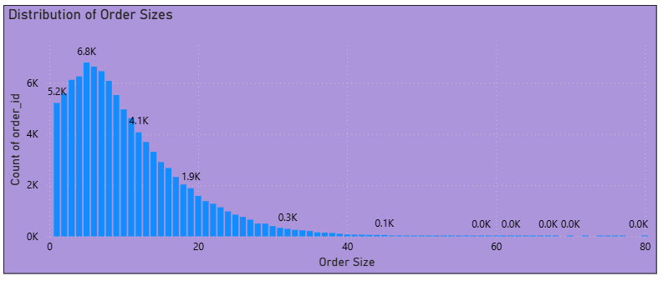
- What is the average reorder rate for products in each aisle?
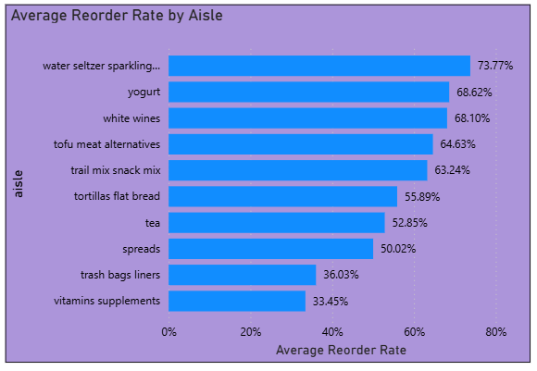
- How does the average order size vary by day of the week?
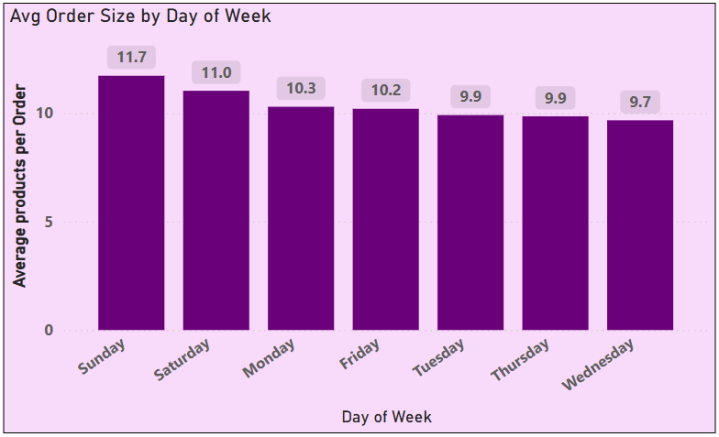
- What are the top 10 users with the highest number of orders?
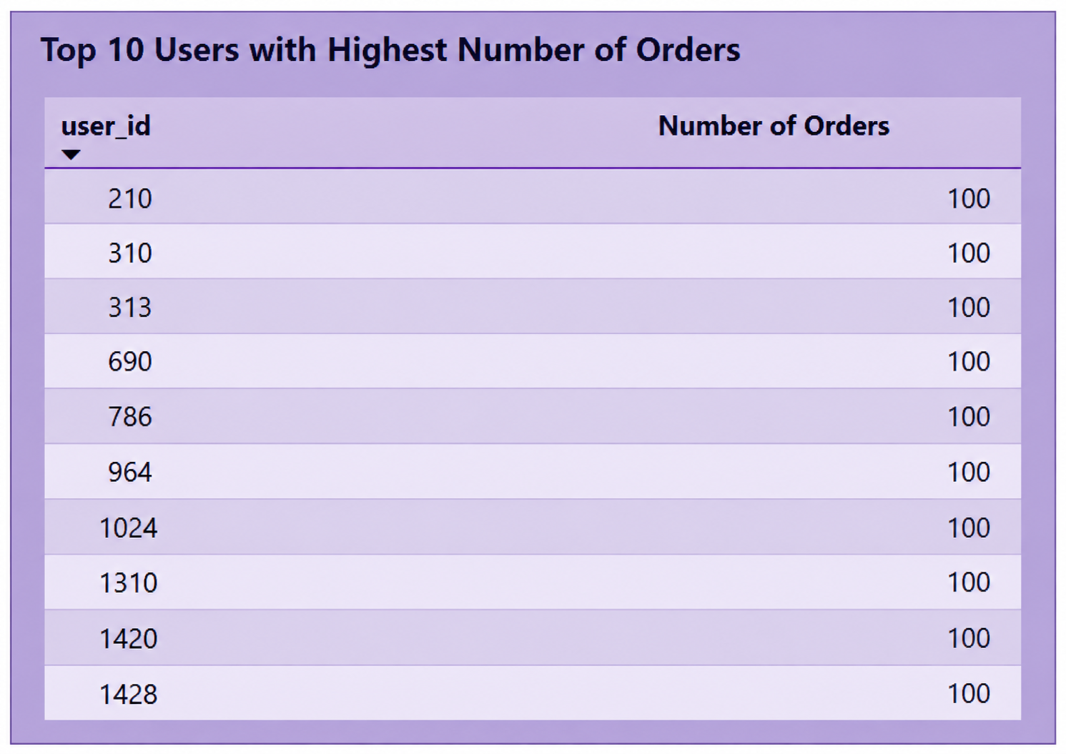
- How many products belong to each aisle and department?

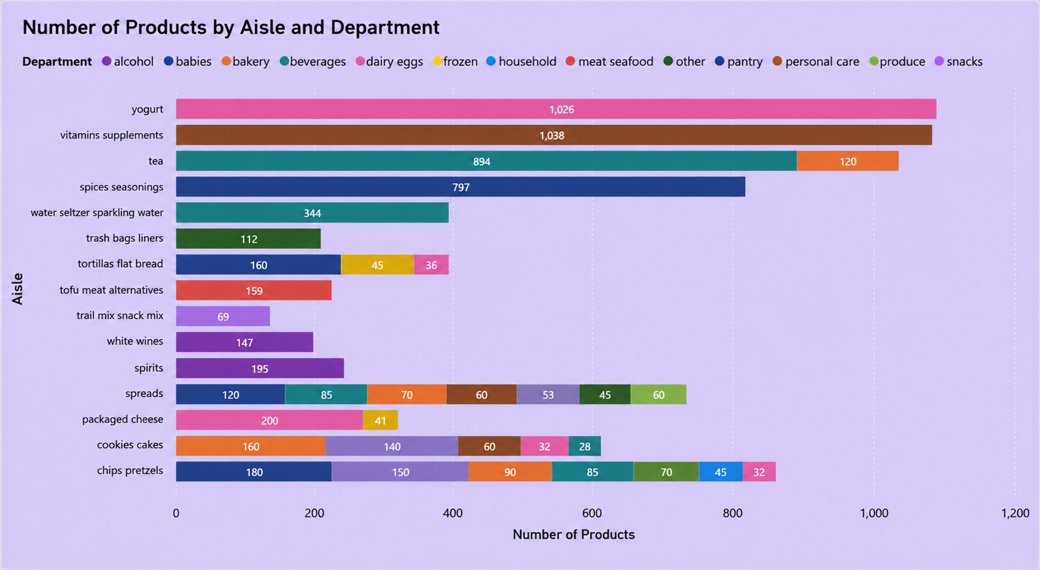

DASHBOARD 1: Product & department Analysis
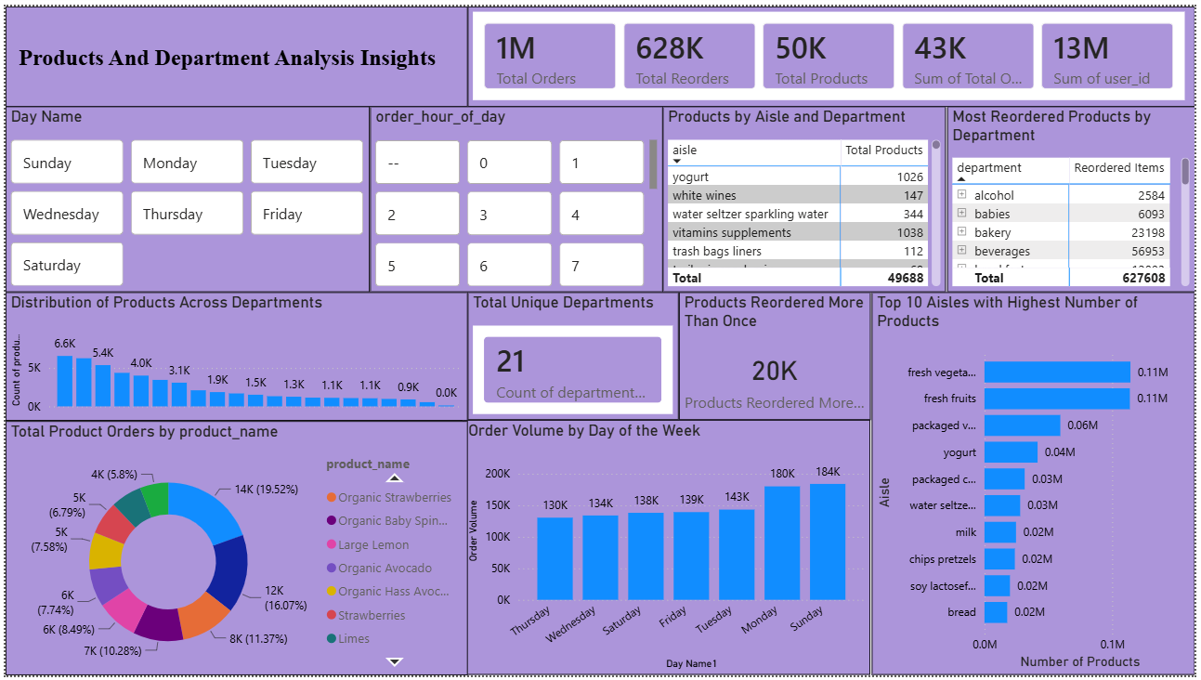
DASHBOARD 2: Customer Purchasing & Order Behavior
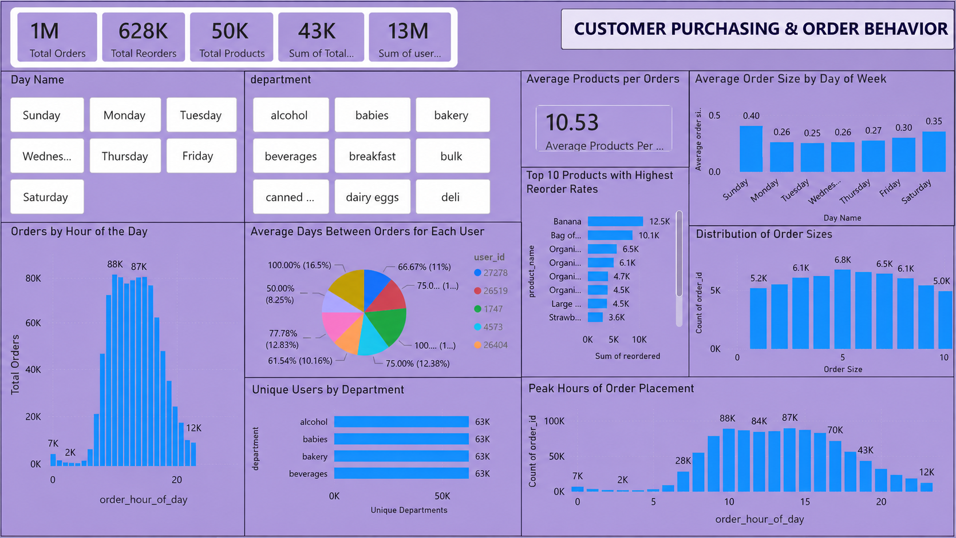

DASHBOARD 3: Market Analysis
